# How to change your password

1. Click on the sign in menu item A black and blue screen with yellow text

   AI-generated content may be incorrect.
2. Click on forgot your password

1. Enter your email address and click get new password

1. An email will be sent to you with a link to change your password.
2. NB IF THE EMAIL IS NOT IN YOUR INBOX, LOOK IN THE JUNK FOLDER IT MAY BE THERE. IF NOT SEND ME VIA Hobdens info[@hobdensmanage.co.uk](mailto:jade@hobdensmanage.co.uk)
3. Open the link in the email, it will look a little odd as the website will create a random password automatically, you can use this or delete it and set your own password.

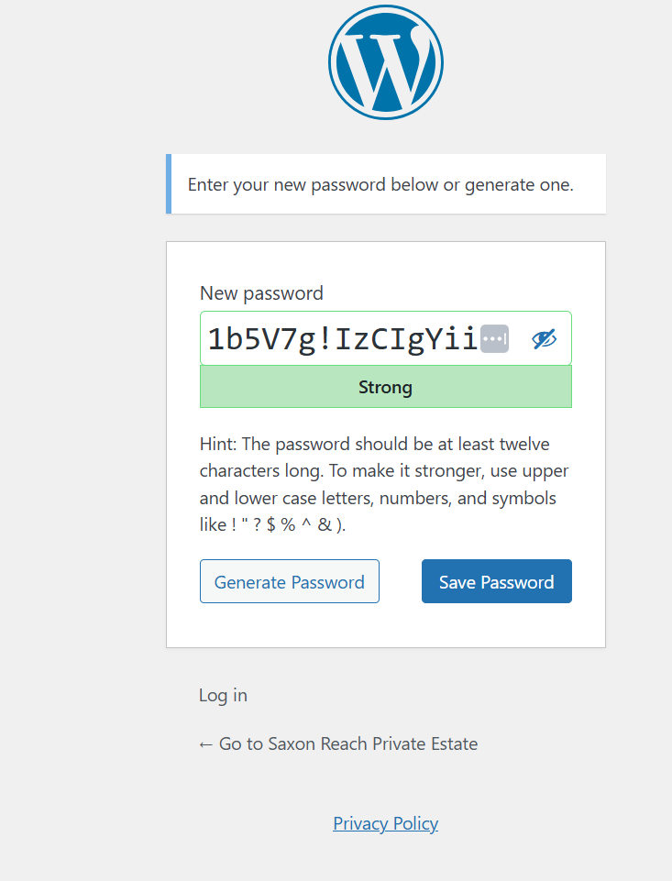

1. Ie to set a password of “SaxonReach@123” for example (don’t actually use this password yourself for security reasons). Delete the automatic password in the above and put in your new password and press save password as shown below

1. You should get a message like shown below, and your password has been set, you should now be able to login to the website with your new password

